

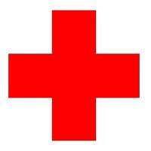 Guidelines for Dealing

with Accidents

Mid Sussex Netball Club is fully committed to safeguarding and promoting the wellbeing of all clients & participants.

Mid Sussex Netball Club believes that it is important that clients, instructors, coaches, administrators and parents/carers or guardians associated with Mid Sussex Netball Club should, at all times, show respect and understanding for the safety and welfare of others.

In the event of an accident or incident you should -

- Stay calm but act swiftly and observe the situation. Is there danger of further injuries?
- Listen to what the injured person is saying.
- Alert the first aider who should take appropriate action for minor injuries.
- In the event of an injury requiring specialist treatment, call the emergency services.
- Deal with the rest of the group and make sure they are adequately supervised.
- Do not move someone with major injuries. Wait for the emergency medics.
- Contact the injured person’s parent/carer.
- Complete an incident/accident report form.

